*A Mini-project report on*

**ROLLBALL PLAYER MANAGEMENT SYSTEM**

**(SPORTS MANAGEMENT SYSTEM)**

*Submitted in partial fulfilment for the award of the degree of*

**MTSE**

*By*

**TEAM MEMBERS**

**R.V.S. TEJA KRISHNA (17MIS7085)**

**P.H.S. ABHIRAM (17MIS7073)**

**K. VARUN TEJA CHOWDARY (17MIS7156)**

**COURSE NAME**

**PRODUCT DEFINITION AND VALIDATION (CSE 3020)**



**School of computer science engineering**

**JUNE 2020**

**TABLE OF CONTENTS**

|  |  |  |
| --- | --- | --- |
| **1** | **INTRODUCTION** | **3-12** |
| 1.1 | Introduction | 3 |
| 1.2 | Literature Survey | 3 |
| 1.3 | Problem Statement | 3 |
| 1.4 | Study of System | 4 |
| 1.5 | Scope of the Project/Product | 4 |
| 1.6 | Modules | 5 |
| 1.7 | Testcases | 6-9 |
| 1.8 | Functionalities | 10-11 |
| 1.9 | Future Work | 12 |
| 1.10 | References | 12 |
| 1.11 | Challenges | 12 |
| 1.12 | User Manual | 12 |
| **2** | **LIST OF FIGURES** | **13-19** |
| 2.1 | Software Architecture | 13 |
| 2.2 | UML Diagrams | 14-19 |

**1.1 Introduction**

The reasons why this projects started is that previously some of the talented players have missed some events in this association because of lack of information regarding the registration and start dates, and some don’t know where to register how to get registered for the event, so to overcome this problem the project has been started.

**1.2 Literature Survey**

To avoid such problems mentioned in problem statement this project has been started to notify the players or others who wanted to prove themselves in this game, that is to maintain the information of the competitions going to be held and winners of the competitions which are already held, so that when the players or newly registered people will get notification regarding the competitions going to be held under this association.

**1.3 Problem Statement**

This project Roll ball player management system has taken place because there are many talented players in our state for every sport, so to prove their talent they are not getting any opportunities and some people are missing them due to less information about the opportunities.

**1.4 Study of the System**

The target users of the website are players, organizers, coaches from other places. ­To build this project of Roll Ball Player Management System the technologies used are HTML, PHP, MYSQL, CSS, XML, BOOTSTRAP and JAVASCRIPT. The HTML is used for the user interface development to build the static and dynamic Webpages to make the website more user-friendly for the users even if they are new to the website, and PHP is used to connect the front end static and dynamic webpages to the database so that the information from the user entered in the website will be stored into the database, and the database used for connecting the website to store the details of the players entered is MYSQL from XAMPP server, and to make the website more colourful and attractive we used CSS and BOOTSTRAP for styling the websites and XML is used to view the contact details because it has the ability to describe the information in our own tag names, and for the validation of forms and validating whether actual user is logging into the website, or any wrong passwords entered by the user.

**1.5 Scope of the Project**

The projects main aim is to make the registrations online, and maintain the details of the players who have registered for particular competition. The benefits of this project are whenever the organizers will add an event the players who subscribed (created an account) will get a mail notification regarding the event and for those who are not registered has to check the website to get the details of the event. The players need not go anywhere to get registered he/she can easily register from his mobile by logging into this website.

**1.6 Modules**

There are two modules Player module and Admin module.

1.6.1. Player module

This module contains all the pages required for player where he can view, register and create account where all his details and statistics are stored. The player can register for hi interested competition and participate as per details mentioned in registration. All his achievements are stored and can be generated if required.

1.6.2. Admin module

Admin module contains all the main backend processes for player which refreshes all the player details by retrieving continuously from the DB. Admin is everything for a project/product where he can place events, edit events, generate reports and announce achievers list. More over admin stores all the data required for a player at backend through DB.

**1.7 Testcases**

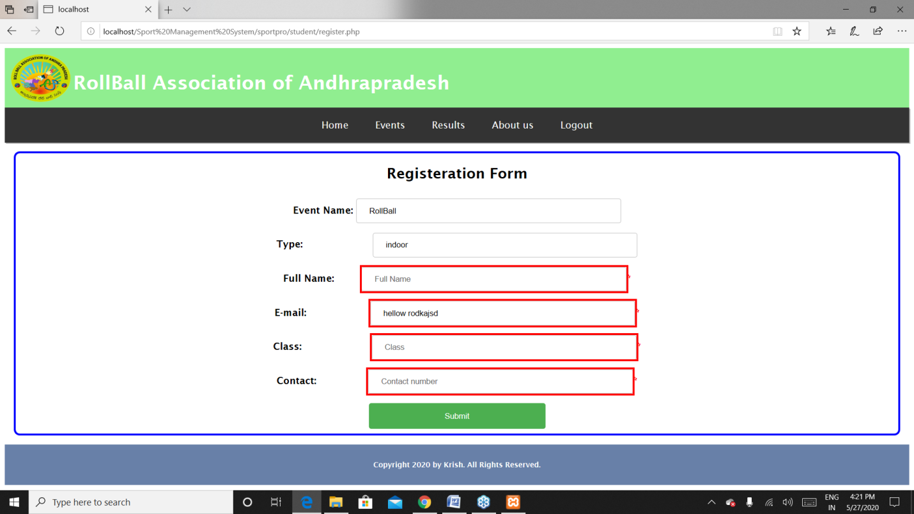

**Fig 1.7.1** Registrations page – if the players did not enter the details of themselves and click on submit then it highlights that they are required.

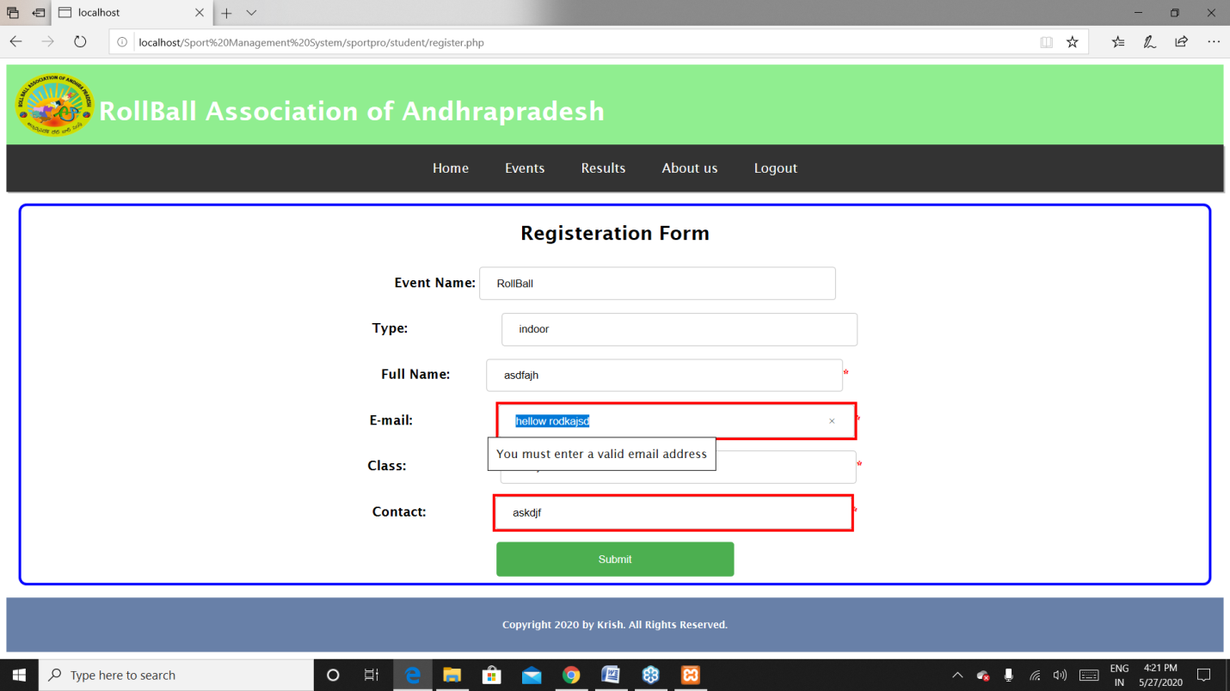

**Fig 1.7.2** Registrations page – if the players did not enter the email properly then it will show an error to enter the mail correctly.

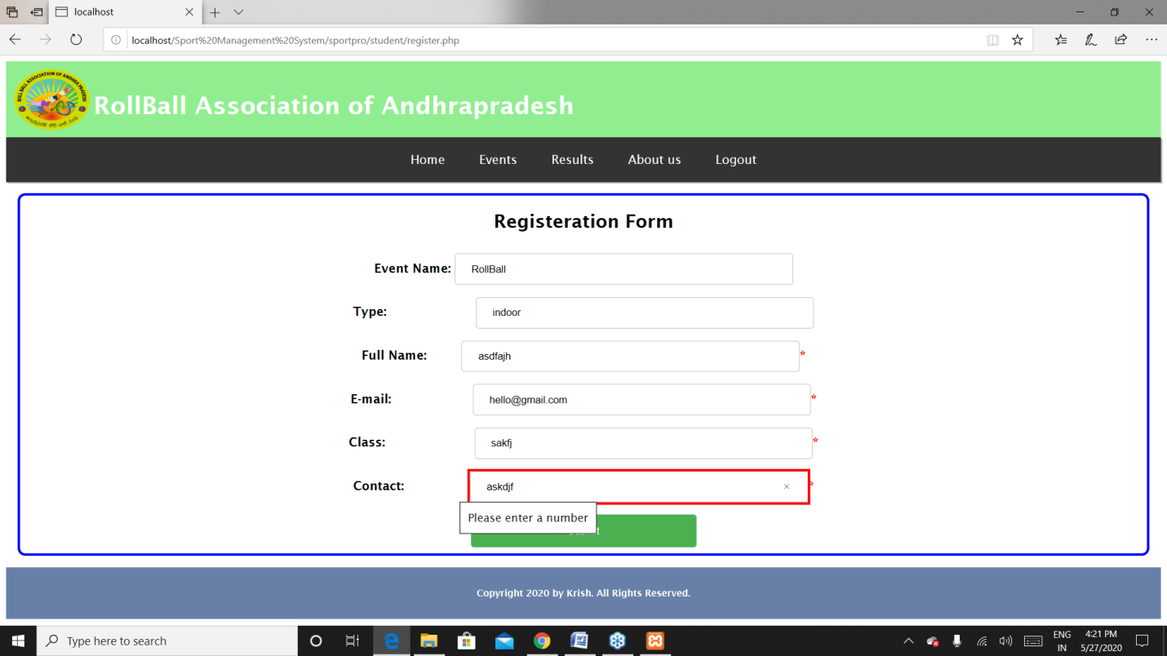

**Fig 1.7.3** Registrations page – if the players did not enter the mobile number correctly that is entering string type instead a number.

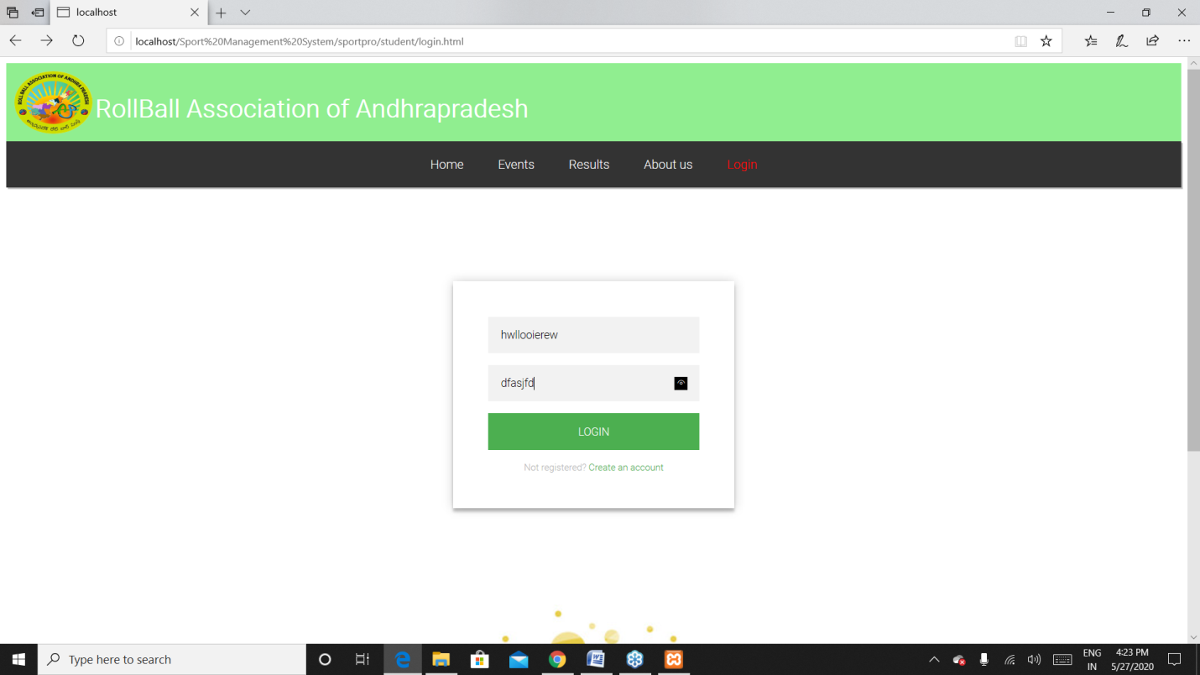

**Fig 1.7.4** login page – Entering the wrong credentials and clicking on login leads to next picture

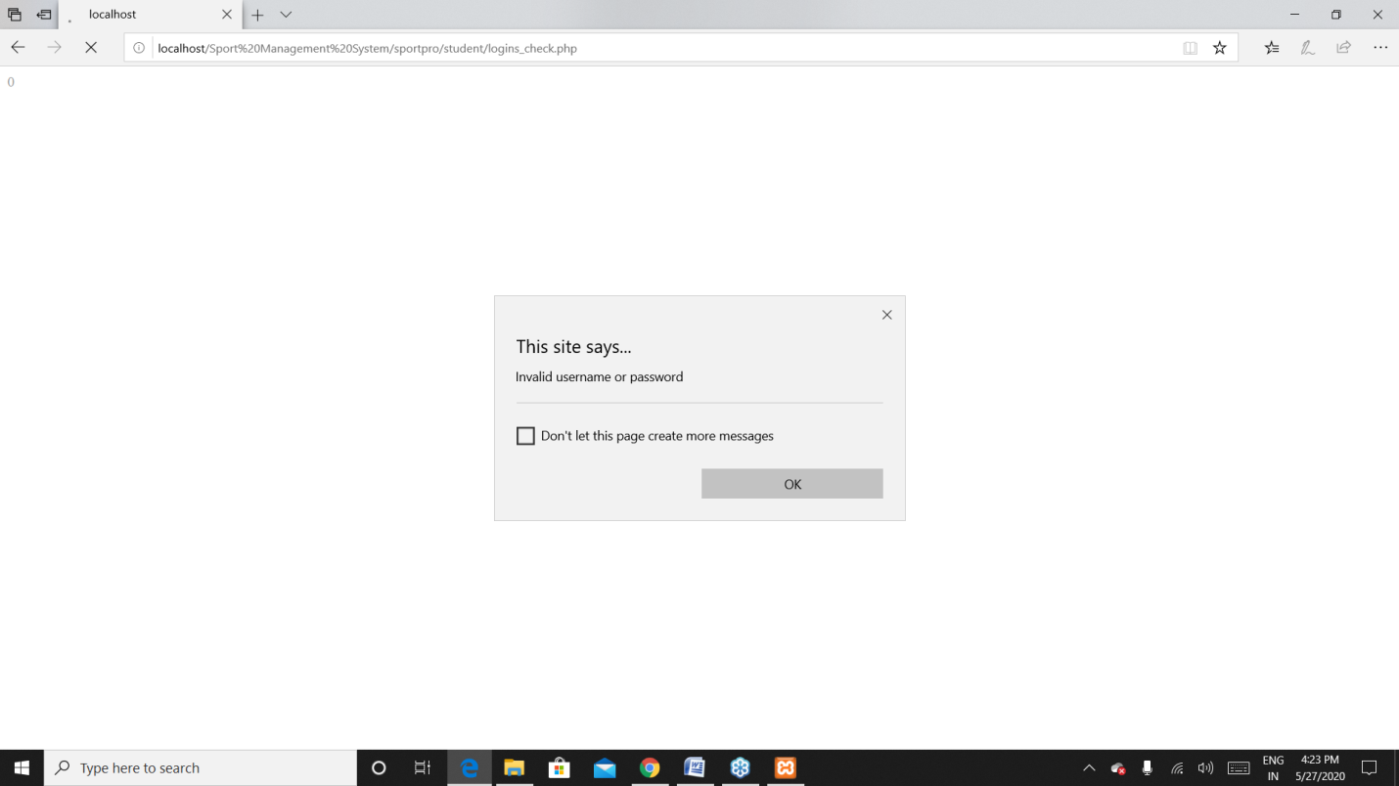

**Fig 1.7.5** login page – if the player enters the wrong credentials while logging in it show a dialogue box.

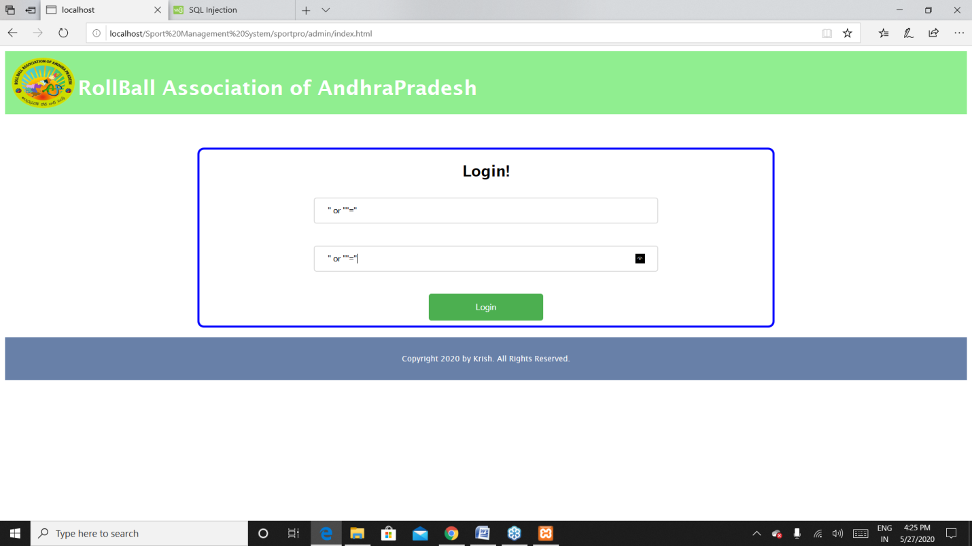

**Fig 1.7.6** admin login page – if any hacker wants to log into admins page using some sql injections as above it will not be possible because xampp provides default security for the database to avoid sql injections if so given will display a dialogue box as next picture.

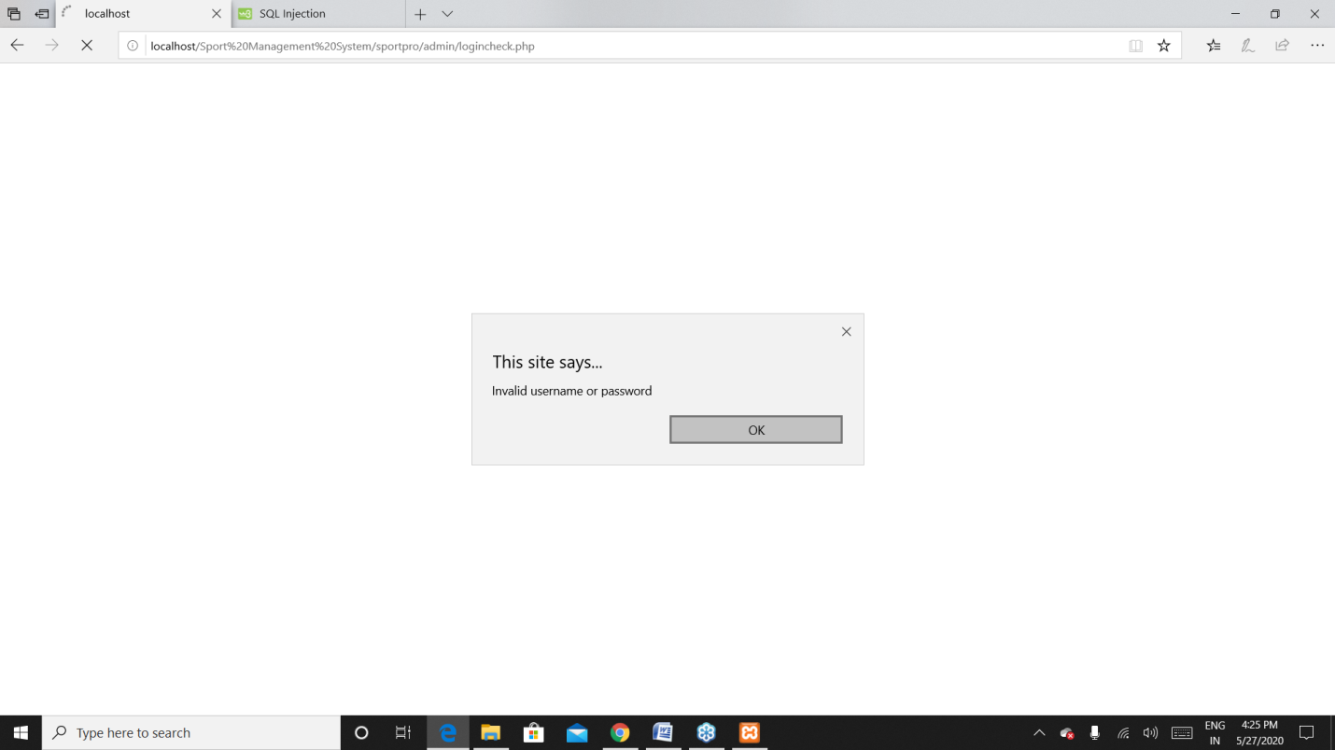

**Fig 1.7.7** admin login page – trying for sql injections.

**1.8 Functionalities**

**1.8(a). Player modules**

**1. 8(a).1. Home page**

This is the common page for each and every player where it gives a glance of all the other modules on the player side, It has a grid of sliding images which attracts players and shows display of latest and upcoming events.

**1. 8(a).2. Events page**

This page contains all the events going on with event name and description about that event and start time and end time of events. Here players are able to register for the events they are interested in.

**1. 8(a).3. Results page**

In the results page there will be a display of table containing winners of particular competition held at particular time. Here data is retrieved from results table at backend which is updated by admin from his page.

**1. 8(a).4. About us page**

Here in the about us page we will provide player with contact details of event managers, if the players have any queries, they can contact that particular manager through mail or phone as mentioned. Along with contact details we have provided location of the head office which is very useful to navigate from anywhere.

**1. 8(a).5. Login page**

In the login page the player can give his credentials and login to access registrations for events planned. And if the player does not have an account, he can create a new account using the signup option given below where he/she has to fill the details according to fields asked.

**1.8(b). Admin modules**

**1.8(b).1. Login page**

Login page for admin is very confidential and accessible only for admin with his own secure credentials. After logging in he can operate the whole operations of player and display of players in the way beneficial for the players.

**1.8(b).2. Add Events page**

Events are the most important for any player where he can showcase his skills. Here in add events page admin adds events going to be held with all the descriptions and dates and times.

**1.8(b).3. Edit Events page**

After adding events if there is any odd for conducting competitions we need to update and notify for all the players which is very important thing and so we have kept this module of edit events which allows admin to edit event details and this reflects in each and every players account.

**1.8(b).4. Reports page**

Report generation is most important concept in each and every software project. Here we can generate reports of players who are registered for which events and all this data is retrieved from backend tables in phpMyAdmin.

**1.8(b).5. Results page**

Results page is useful to update results of competitions held and this data will go to results table and is retrieved from player end.

**1.9. Future Work**

In this project we have worked on placing events and editing them if needed and a player can register for them on their interest where they can participate in those events. And admin is able to generate reports of registered players list. In future if we add stores module which contains all the sports equipment of all brands and ate reasonable prices which adds a great step for our project.

**1.10. References**

1. [**https://www.geeksforgeeks.org/html-tutorials/**](https://www.geeksforgeeks.org/html-tutorials/)
2. [**https://www.w3schools.com/html/**](https://www.w3schools.com/html/)

**1.11. Challenges**

We have faced several challenges during the project one of them is keeping the project secure from sql injections and we achieved it and made our project free from sql injections and next some of the issues while generating reports are resolved. One of the major challenges is to intimate all players about edited events and we solved it through adding edit events page for admin which will refresh all the players pages after updating.

**1.12. User Manual**

We have designed project in a way like in negligence of age group every person can understand what to click or what to type and they can get notification pop ups in case of any happenings or not happenings which makes user very convenient to work.

**2.1. Software Architecture**

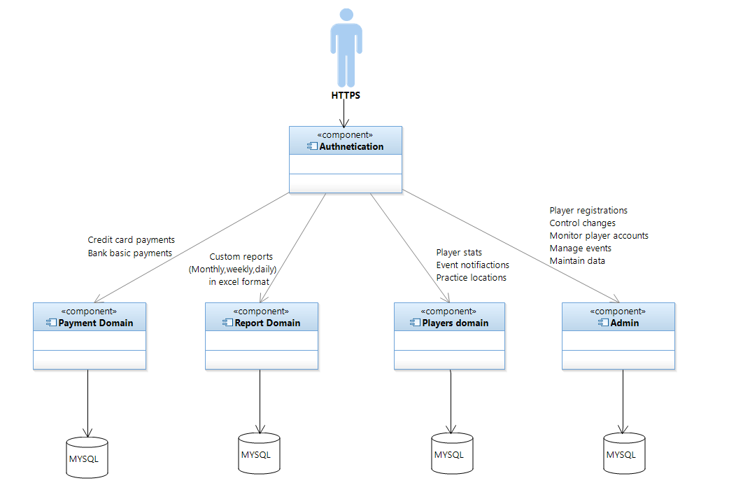

**Fig 2.1 Architecture of the project**

This diagram shows how the project is connected to the database and how the website is authenticated by the user. This tells the information running the backend of the website

**2.2. UML Diagrams**

**2.2.1. USE CASE DIAGRAM**: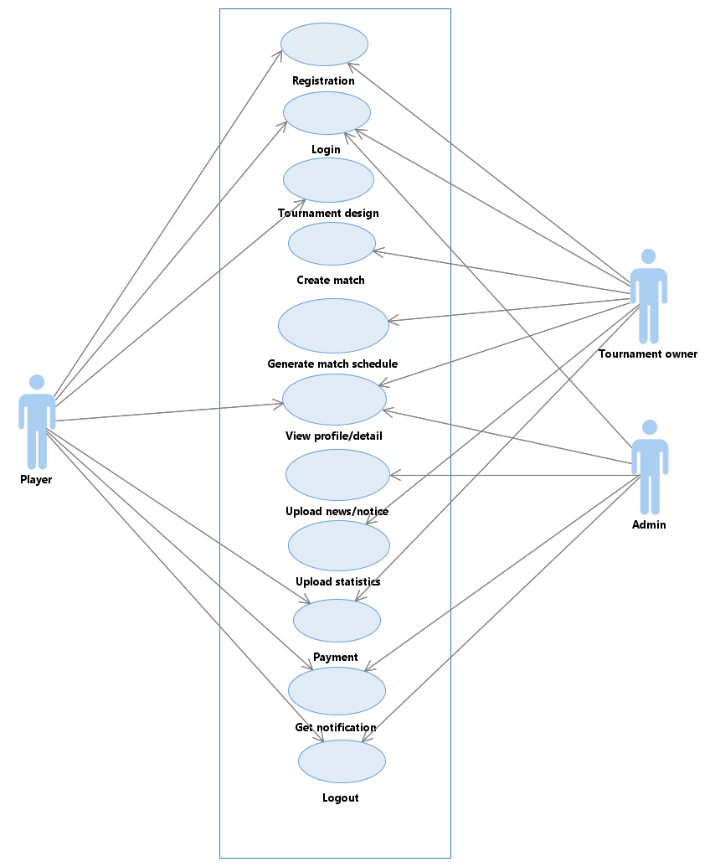

**Fig 2.2.1 Use case diagram**

According to the above diagram the player can be able to register to the competitions and get logged to get the details of the events and tournament owner(organizer) will take care of creating a match and a schedule and managing all the works of the tournament, the admin can also do the same thing as the tournament owner and some extra functionalities for the admin to maintain the website information.

**2.2.2. CLASS DIAGRAM:**

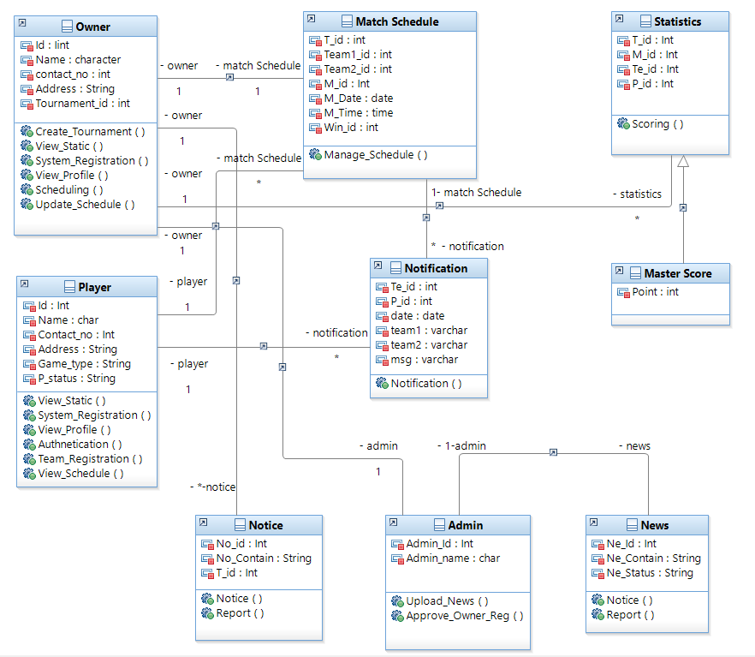

**Fig 2.2.2 Class Diagram**

In this diagram we can get the information about each activity, which are the details going to be stored in the database and the operations done by every class i.e., like organizer can create a tournament, update the schedule and such operations.

**2.2.3. COLLABORATION DIAGRAM:**

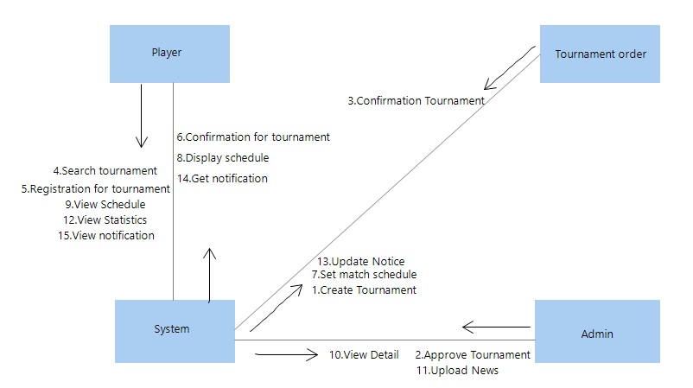

**Fig 2.2.3 Collaboration diagram**

This diagram shows about the actions performed between the classes so that the access of operations can be given to the particular class to avoid the operation clashes.

**2.2.4. SEQUENCE DIAGRAM:**

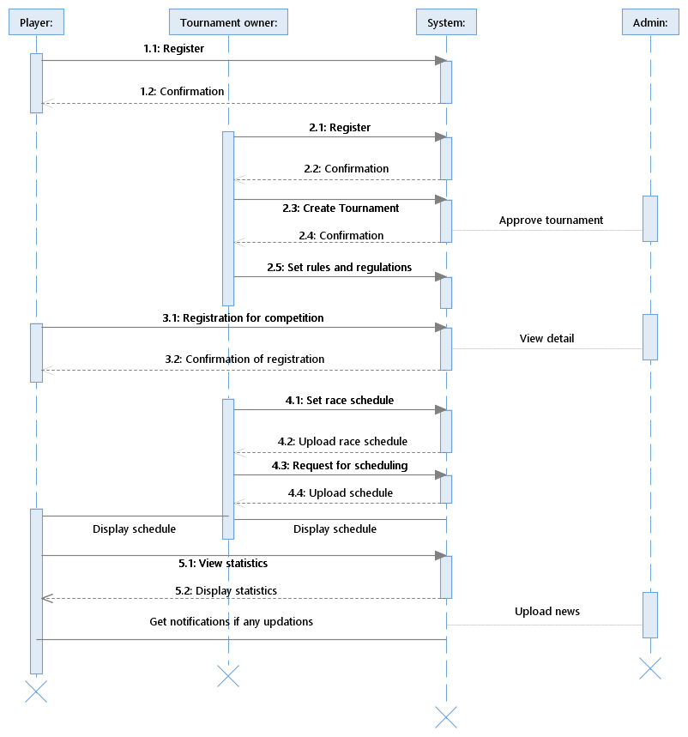

**Fig 2.2.4 Sequence Diagram**

The sequence diagram shows the sequential order of the process of how user will interact with the system and how the system will interact with database to develop the project easily.

**2.2.5. ACTIVITY DIAGRAM:**

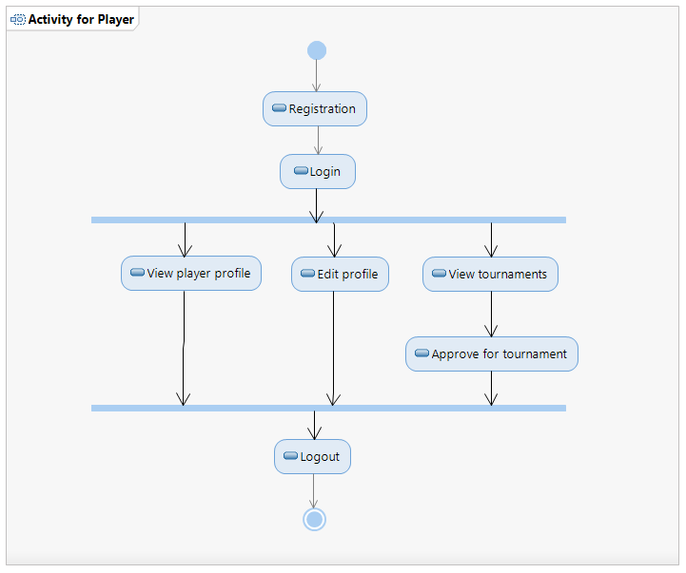

**Fig 2.2.5.1 Activity diagram for player**

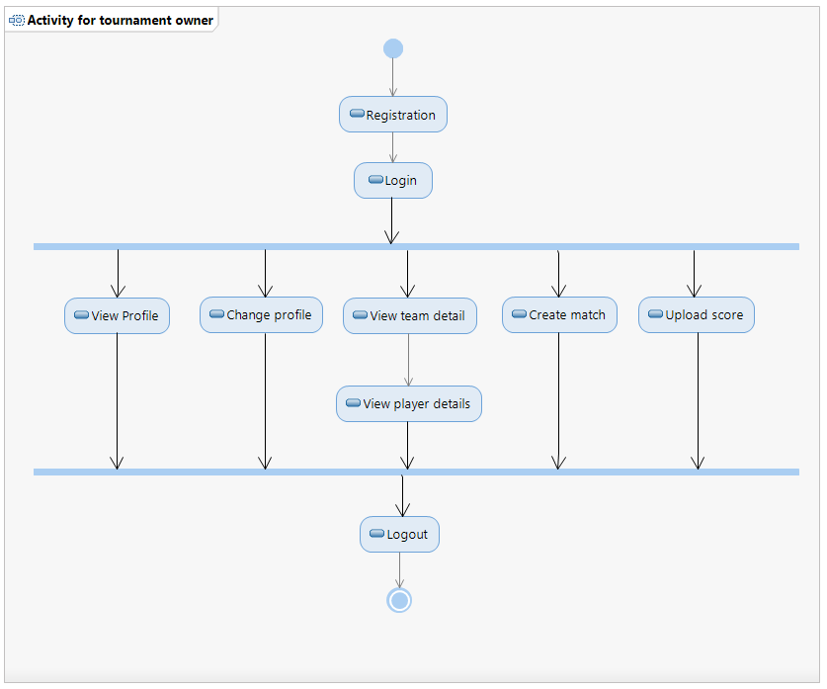

**Fig 2.2.5.2 Activity diagram for admin**

The activity diagram tells about the operations done by any user in a detailed manner. To implement the operations for the particular users it can be useful for the developer to complete the project with this activity diagram.

**----------------------------------- END OF REPORT -----------------------------------**